**Online Tailoring Application (Web Application)**

**Project Abstract**

This project development purpose is to provide better services and good keeping of records, Data security, data integrity, and quick search and not use of paper documentation. For customers and decision making information the project used mainly tackled management process. The System user must have to log in using his/her username and password to ensured security and authentication. After successfully login into a system, User can make and order, check dress status and give feedback. The administrator can manage customer information’s and update records. This project promote automate system for user ease and time safe.

**Introduction**

An online tailoring Application is an automated system is to help the management of tailoring activities. The system will provide online Services to it user for example:

1. Measurement Submission.
2. Order a cloth
3. Select tailors.
4. Hire an expert for measurement.
5. Help for the proper keeping of records.
6. Pick up services.
7. Feedback

This system ensures the right information availability, Safety of information also access and retrieval. For better use and more efficient than the existing manual system.

The system perform some basic functionality which are the following:

**Measurement Module**

The main purpose of the measurement module is to manage the measurement of data. Admin can see the list of all the measurements. We make CRUD (Create, Read, Update and Delete) operation of measurement data. The features of this module are:

* Admin is able to manage all the measurements.
* Admin is also able to Edit/Delete the measurement
* Admin is able to see the list of all the measurement
* The customer is able to see all his/her measurements.

**Order Module**

The Order module is one of the core modules of the tailoring app. The customer is able to order for cloth made which is mange by admin and check all the list of order categories and filter it according to customers. The customer can also see the order detail.

• Admin is able to manage all the orders.

• Admin is also able to Edit/Delete the orders.

• Admin is able to see the list of all the orders.

• The customer is able to see all his/her orders.

**Category Module**

This module is to show for customers which is most important how customer want cloth form our site. All the categories of cloth we collated is tracks all the information and detail of the categories. Some of the feature of this module is

* Admin is able to add new category.
* Admin is able to see the list of category details.
* Admin is able to Edit/update/Delete the record of the category.
* These category form are validated on client side using mean.js.

**Customer Module**

The main purpose of this module is to facilitate all the functionality according to the customer. This Module tracks all the information and details of the customer. We build all types of data operation of Customer (Create, Read, Update, and Delete). Admin can perform each and every operation on data but the customer is only able to see his/her data. The main feature of this module is:

* Admin is able to add new Customers.
* Admin is able to see the list of Customer details.
* Admin is able to edit/update/Delete the record of the Customer
* Customer can see his/her detail
* The customer is also able to update and delete his/her detail.

**Registration Module**

This module help user and customer to register on tailoring app also this module tracks all the information and details related to registration. Features of this module are:

* Admin is able to add new Registration.
* Admin is able to see the list of registration details.
* Admin is able to edit/update/Delete the record of the registration.

**Motivation and Scope**

The Online Tailoring Management System must check the validity of the user and allow the user to register for submission of measurement to the selected tailor. It maintains user information to generate reports about the tailor shop. System administrators and Customers are the main users of the Online Tailor Management System. It allows the customer to check the status of their garments for example order is complete or not for collection.

The System provides various information like:

1. Cost
2. Fabric type
3. Which garment customer wants his/her dress.
4. When the customer wants his/her dress.
5. Which type of material want to be used.
6. The quantity he needs or wants to make.
7. Check the total cost after complete the form.

The online Tailoring Management System provide Payment method either via mobile money transfer services like easy paisa, jazz cash and other ATM service like a debit card

**Related Work**

The services and functionality we provide in our application can be found as an individual, specific websites and applications and all these, combined at a single platform for a specific domain is seen in the market but we provide all functionality and our domain is for generic. Some of the apps and websites are,

Mtailor:For online cloth measurements and shipment. [1], ZTailor:For suit or tux delivery. [2], Etailor Master: For pick,stitch and deliver cloth. [3].

**System Architecture and Features**

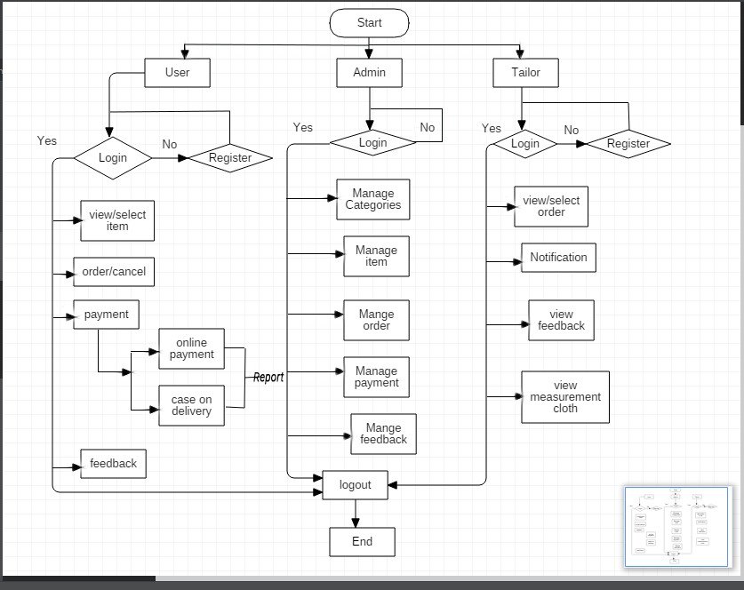

**Goals and Objectives**

1. Aim to update the manual tailoring system to automate the system and maintain a customer, data security, and product database and user rights.
2. The cloth that wants to be made by the user can able to send their measurements to their tailors.
3. For Customer ease we maintain all record he/she can use his measurement submission use again and again or update it whenever he/she want to made again.
4. To provide information about the cost, the fabric type, the urgency at which a customer wants the dress finished, the type of material to be used and quantity in terms of pairs needed.
5. The total cost which is computed depends on the user-selected fabric, type of material, quantity, and duration.
6. For client satisfaction, Send a message to it provided number for his/her order complete status.
7. To enable report generation: it is able to give a report of finished garments to the clients for collection and bookings made, an administrator is able to view all the customers and their details, finished garments and all the bookings made.

**Individual Tasks**

There are 5 main modules in the project; some of these with further multiple sub-modules. i.e.

1. **Measurement Module**
   1. Requirement Gathering
   2. Design
   3. Implementation
   4. Testing
2. **Order Module**
   1. Requirement Gathering
   2. Design
   3. Implementation
   4. Testing
3. **Category Module**
   1. Requirement Gathering
   2. Design
   3. Implementation
   4. Testing
4. **Customer Module**
   1. Requirement Gathering
   2. Design
   3. Implementation
   4. Testing
5. **Registration Module**
   1. Requirement Gathering
   2. Design
   3. Implementation
   4. Testing

These tasks are divided as follows,

|  |  |  |
| --- | --- | --- |
| **Arman Ali**  **(CIIT/FA17/BSE-058/ATK)** | **Muhammad Ibrahim**  **(CIIT/FA17/BSE-060/ATK)** | **Muhammad Shoaib**  **(CIIT/FA17/BSE-070/ATK)** |
| * 1. Requirement Gathering | 1.2 Design | 1.3 Implementation |
| 1.4 Testing | 1.3 Implementation | 1.4 Testing |
| 2.2 Design | 2.1 Requirement Gathering | 2.3 Implementation |
| 2.3 Implementation | 2.4 Testing | 2.1 Requirement Gathering |
| 3.1 Requirement Gathering | 3.2 Design | 2.4 Testing |
| 3.3 Implementation | 3.3 Implementation | 3.1 Requirement Gathering |
| 3.4 Testing | 4.1 Requirement Gathering | 3.4 Testing |
| 4.2 Design | 4.3 Implementation | 4.3 Implementation |
| 4.4 Testing | 5.1 Requirement Gathering | 5.2 Design |
| 5.1 Requirement Gathering | 5.2 Design | 5.3 Implementation |
| 5.3 Implementation | 5.4 Testing | 5.4 Testing |

**Gantt chart**

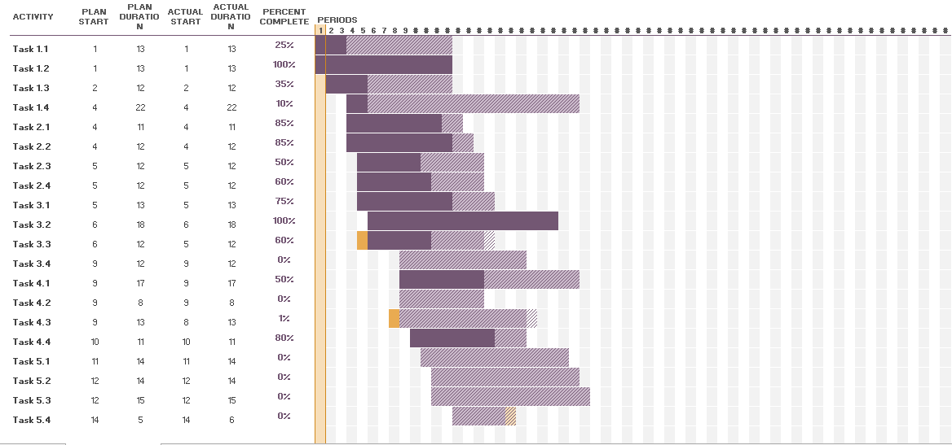

**Tools and Technologies**

* MS Visio / Star UML
* Bracket / Sublime /Atom
* Mean
* Adobe Photoshop
* Mongo DB
* Express
* Angular.js
* Node.js
* JavaScript

Or we can use *React.js and vue.js* instead of Node.js.

**Recommendation:**

The customer is able to review about tailor and product of our site. In which he/she write and review and gave a rating about what he/she recommends to others.

Tailor is also able to write and gave ratings to customers.

Based on these rating systems we configure and recommended the best tailor and best customer of our site.

References

[1] Inc., A. (n.d.). Retrieved from Mtailor: <https://www.mtailor.com/>

[2] Inc., B. (n.d.). Retrieved from Ztailors: <https://www.generationtux.com/>

[3] Inc., O. (n.d.). Retrieved from Etailor master: <https://etailormaster.com/>

Appendix A

*Include here the 1st page of Turnitin Report*

Every supervisor has his/her own Turnitin account. If not then supervisors are requested to get the account from Library as soon as possible.